

The Superior University

|  |  |  |
| --- | --- | --- |
| Name: Abdul Moeez | Roll No: 017 | Course: PAI Lab |
| Semester: 4th | Section: BSAI 4A | Department: Artificial Intelligence |
| Submitted To: Sir Rasikh | Total Marks: | Date: |

**Lab 7&8**

# **Stock Price Tracker Documentation**

## **Overview**

The **Stock Price Tracker** is a web application built using **Flask** (a Python web framework) and the **Alpha Vantage API** (a free financial data API). The app allows users to:

1. **Fetch real-time stock data** (e.g., open, high, low, close, volume, and last updated time).
2. **View historical stock prices** in an interactive line chart using **Chart.js**.

This project is designed to help users track stock prices and visualize historical trends in an easy-to-use interface.

## **Why We Built This**

1. **Learning Purpose**: This project is an excellent way to learn how to:
   1. Build web applications using Flask.
   2. Integrate third-party APIs (Alpha Vantage) into a web app.
   3. Use JavaScript libraries (Chart.js) for data visualization.
   4. Handle JSON data and render it dynamically in a web page.
2. **Practical Use**: The app provides a simple and intuitive way for users to:
   1. Monitor stock prices in real-time.
   2. Analyze historical price trends for better decision-making.
3. **Open Source**: The project is built using open-source tools and APIs, making it accessible and customizable for developers.

## **Features**

1. **Real-Time Stock Data**:
   1. Fetch and display the latest stock prices (open, high, low, close, volume, and last updated time).
2. **Historical Price Chart**:
   1. Visualize the stock's historical closing prices for the last 30 days using an interactive line chart.
3. **User-Friendly Interface**:
   1. A clean and responsive design that works on all devices.
4. **Free API Integration**:
   1. Uses the Alpha Vantage API, which provides free access to financial data.

## **How It Works**

1. **User Input**:
   1. The user enters a stock symbol (e.g., AAPL for Apple) in the input field and clicks "Get Price."
2. **Backend (Flask)**:
   1. The Flask app sends a request to the Alpha Vantage API to fetch:
      1. Real-time stock data (using the TIME_SERIES_INTRADAY endpoint).
      2. Historical stock data (using the TIME_SERIES_DAILY endpoint).
3. **Frontend (HTML + Chart.js)**:
   1. The app displays the real-time stock data in a table.
   2. The historical data is rendered as a line chart using Chart.js.
4. **Output**:
   1. The user sees the stock's current price and a historical price chart.

## **Technologies Used**

1. **Backend**:
   1. **Flask**: A lightweight Python web framework for handling HTTP requests and rendering templates.
   2. **Alpha Vantage API**: Provides real-time and historical stock data.
2. **Frontend**:
   1. **HTML/CSS**: For structuring and styling the web page.
   2. **Chart.js**: A JavaScript library for rendering interactive charts.
3. **Dependencies**:
   1. **Flask**: For building the web app.
   2. **Requests**: For making HTTP requests to the Alpha Vantage API.

## **How to Set Up and Run the Project**

1. **Get an Alpha Vantage API Key**:
   1. Sign up for a free API key at [Alpha Vantage](https://www.alphavantage.co/support/#api-key).
   2. Replace '3F3QZWLHPZAL57IZ' your API KEY here in app.py with your API key.
2. **Run the Flask App**:

python app.py

1. **Access the App**:
   1. Open your browser and go to <http://127.0.0.1:5000/>.

## **OutPut:**

The API Limit got exceed that’s why it’s not showing results. I also change API’s but it didn’t work because of daily limit.

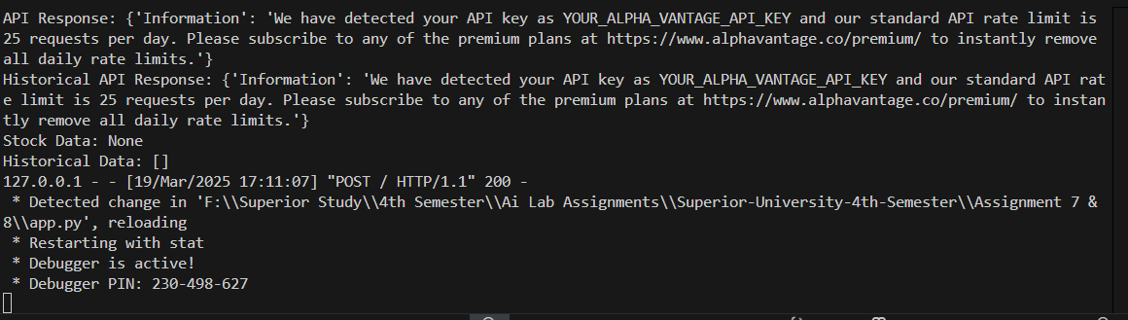

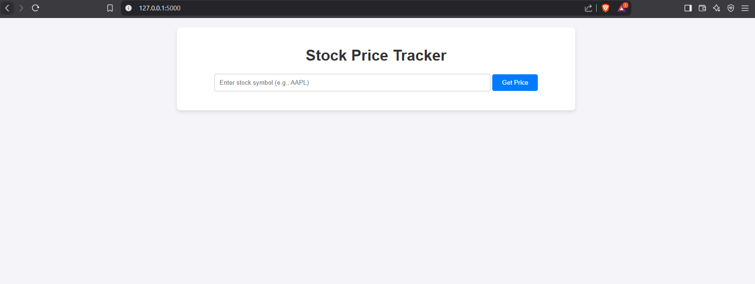

## **Conclusion**

The **Stock Price Tracker** is a simple yet powerful tool for monitoring stock prices and visualizing historical trends. It demonstrates how to integrate APIs, build web applications, and create interactive data visualizations. Whether you're a beginner or an experienced developer, this project provides a solid foundation for building more advanced financial applications.

Let me know if you need further assistance or enhancements! 🚀